**AMBER**

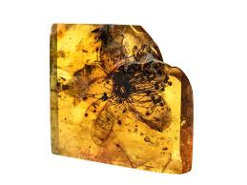 **Name:** Mexican Amber

**Brand:**  Lalique

**Model#:** 003

**Color:** Honey

**Price: $50 million**